The Peace Guidebook: How to Cultivate Hope, Healing and Harmony for the Good of Humankind

FOR IMMEDIATE RELEASE
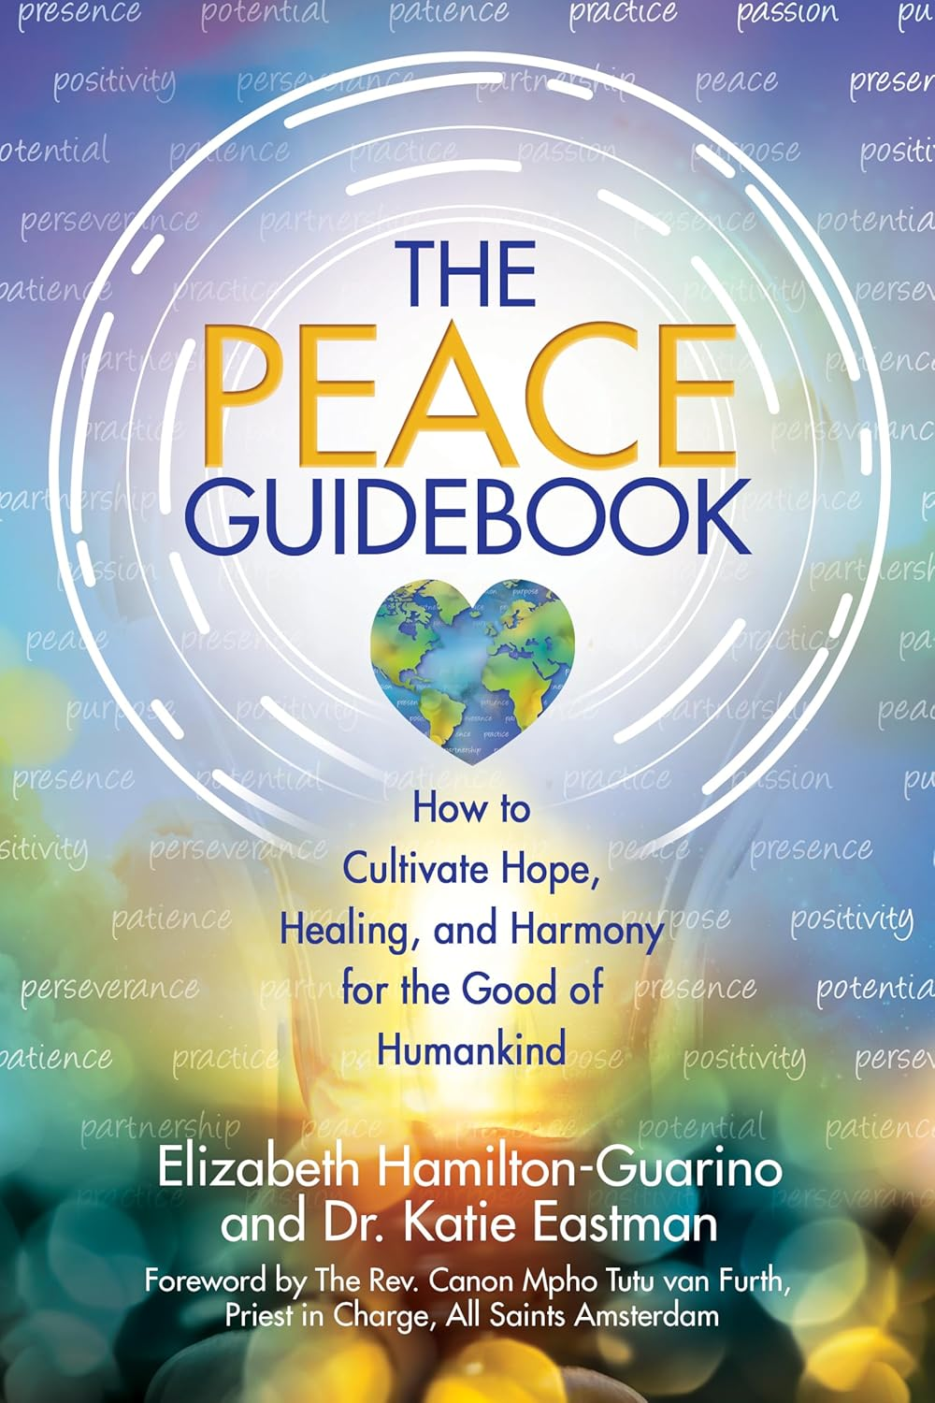
Portland, Maine and Seattle, WA

The Peace Guidebook Invites Readers to Percolate Peace in a World That Desperately Needs It

A Transformative Roadmap for Cultivating Hope, Healing, and Harmony—From the Comfort of Your Own Life
Portland, ME – July 23, 2025 — In a time when division dominates headlines and inner peace can feel out of reach, bestselling author and master life coach Elizabeth Hamilton-Guarino and licensed psychotherapist Dr. Katie Eastman are inviting readers into a radical new vision of peace—one that’s personal, practical, and profoundly powerful.
Their new book, The Peace Guidebook: How to Cultivate Hope, Healing, and Harmony for the Good of Humankind, is the latest installment in their internationally celebrated Guidebook Series (following The Change Guidebook and The Success Guidebook). But this time, the focus is even more urgent: real, grounded peace—in our homes, hearts, communities, and world.
What began as a movement—The Percolate Peace Project—has blossomed into a global invitation for humanity to stop waiting for peace and start practicing it. The Peace Guidebook is that invitation.
“Peace isn’t just the absence of conflict,” says Dr. Katie Eastman. “It’s a conscious way of living, choosing, and relating to one another. And it starts inside of us.”
“We wrote The Peace Guidebook to help 1,000,000 people actively percolate peace through daily actions, reflections, and courageous choices,” adds Elizabeth Hamilton-Guarino. “It’s for anyone who wants to be part of something bigger—but start right where they are.”
✨ A Book Born from Real Life, Not Just Idealism
This isn’t your typical peace-and-love manifesto. The Peace Guidebook blends Elizabeth’s signature coaching voice and life experience as a mother, advocate, and master life coach with Dr. Eastman’s decades of work in grief, trauma, and transformational psychology.
Each chapter walks readers through one of the Ten Principles of Peace: Presence, Potential, Patience, Practice, Passion, Purpose, Positivity, Perseverance, Partnership, and Peace. The book is structured with:
- 78 Peace Points™ (bite-sized practical teachings)
- Real-life stories from people around the world, including teachers, parents, athletes, coaches, comedians, and frontline workers
- Journal prompts, reflection exercises, and interactive tools
- A global movement to join: The Percolate Peace Project
“Peace doesn’t have to be perfect,” says Guarino. “It has to be practiced.”

📖 From Book to Movement
The Peace Guidebook is already rising on bestseller charts during its pre-order phase—reaching #2 on Amazon’s New Release list in Emotions & Mental Health. The co-authors are calling on readers everywhere to preorder the book, join the movement, and begin the simple but revolutionary act of cultivating peace, one breath, one moment, one relationship at a time.
Whether you’re a spiritual seeker, a parent trying to navigate a chaotic world, a leader looking to build a more compassionate culture, or simply someone craving more calm in your everyday life—The Peace Guidebook offers the roadmap you’ve been waiting for.

📚 About the Authors

Elizabeth Hamilton-Guarino is a bestselling author, master life coach, and founder of The Best Ever You Network. Her bestselling books The Change Guidebook, The Success Guidebook, and Percolate: Let Your Best Self Filter Through have transformed the lives of readers worldwide. She has been a leader in personal development and peace education for over two decades.
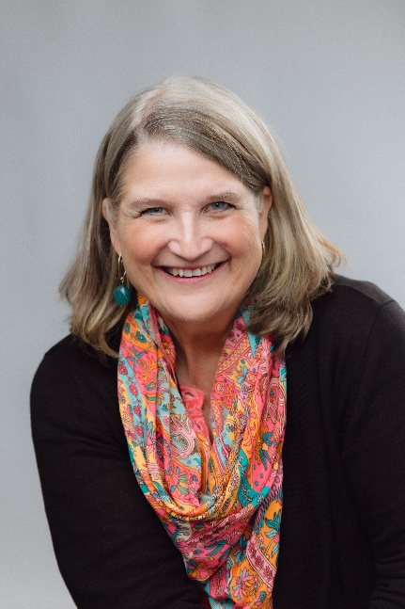
Dr. Katie Eastman is a licensed psychotherapist, speaker, and author of Uplifting: Inspiring Stories of Loss, Change, and Growth Inspired by the Work of Dr. Elisabeth Kübler-Ross. She has spent her career working with individuals, families, and communities to find healing after grief and transformation after loss.

The Peace Guidebook is the third book in The Guidebook Series—a powerful trilogy designed to help readers grow through change (The Change Guidebook), rise into aligned success (The Success Guidebook), and now, become living instruments of peace (The Peace Guidebook).

🌍 Learn More & Join the Movement:
- Visit: www.PercolatePeace.com
- Preorder: The Peace Guidebook on Amazon
- Join the Percolate Peace Project: Facebook Group
- Press inquiries, interviews, and speaking requests: Elizabeth@BestEverYou.com | DrKatieEastmanChangeConsult@gmail.com

“Peace isn’t a distant dream—it’s a choice we make every day. The Peace Guidebook will help you choose it, live it, and lead it.”

Media Questions for
The Peace Guidebook: How to Cultivate Hope, Healing, and Harmony for the Good of Humankind
By Elizabeth Hamilton-Guarino and Dr. Katie Eastman
- What is The Peace Guidebook, and why is it so timely right now?
Tell us about the heart of the book and what inspired you to write it.
- You’ve said peace is not passive—it’s a daily practice. What does that look like in real life?
Can anyone really practice peace, even in chaos or grief?
- The book introduces the Ten Principles of Peace. Could you highlight a few of your favorites and why they matter today?
- What is a Peaceprint™, and how can we begin leaving one in our everyday lives?
What’s the difference between passive hope and active peace?
- You’ve set a bold goal: to help one million people percolate peace. What is the Percolate Peace Project, and how can people get involved?
- Can you describe the structure of the book? How do the stories, Peace Points, exercises, and reflections all come together?
- This book is incredibly inclusive—it features voices from around the world. Tell us about some of the contributors and what their stories add to the guidebook.
- You’re both respected experts in personal development, success, grief, and transformation. How did your unique backgrounds shape the book?
- What are some of the real-life challenges people face when trying to choose peace—and how does your book help them through those?
- You’ve written other guidebooks on success and change. How does The Peace Guidebook complete or continue that journey for readers?
- You talk about “peace disruptors” in the book—what are they, and how can we manage them?
- What’s one Peace Point from the book that someone could apply today to shift their mindset or relationships?
- You’re inviting the world to join you in a global peace movement. What’s your big-picture vision for this book’s impact?
- Who is The Peace Guidebook for? Is it just for personal growth readers—or is there something here for leaders, families, workplaces, and communities too?
- If someone reads only one chapter or does only one exercise—where do you suggest they start?
What’s one powerful takeaway you hope every reader carries with them?

More Information:
The Peace Guidebook – How to Cultivate Hope, Healing, and Harmony for The Good of Humankind
- Publisher: ‎ Health Communications Inc
- Publication date: ‎ April 21, 2026
- Language: ‎ English
- Print length: ‎ 272 pages
- ISBN-10: ‎ 0757326080
- ISBN-13: ‎ 978-0757326080

